***[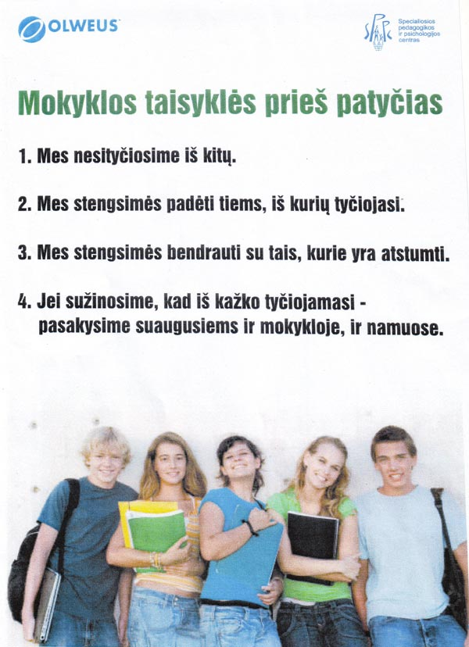](http://jvdm.lt/lt/images/OLWEUS/taisyklesol.jpg)***